

Mehwish Kainat

Roll No: BSEM-F20-026

Subject: Mobile App Development

Assignment: 2

Submitted To: Muhammad Ahmed

Question no 01

<?xml version="1.0" encoding="utf-8"?>

<LinearLayout xmlns:android="http://schemas.android.com/apk/res/android"

xmlns:app="http://schemas.android.com/apk/res-auto"

xmlns:tools="http://schemas.android.com/tools"

android:layout_width="match_parent"

android:layout_height="match_parent"

android:orientation="vertical"

tools:context=".splash"

android:background="@drawable/imag">

<ImageView

android:layout_width="wrap_content"

android:layout_height="wrap_content"

android:src="@drawable/mess"

android:layout_marginTop="200dp"

android:layout_marginLeft="149dp"

/>

<TextView

android:layout_width="wrap_content"

android:layout_height="wrap_content"

android:text="Messenger"

android:textSize="30dp"

android:layout_marginTop="10dp"

android:layout_gravity="center"

android:textColor="#FF9800"

/>

</LinearLayout>

package com.example.massagesender;

import androidx.appcompat.app.AppCompatActivity;

import android.os.Bundle;

import android.telephony.SmsManager;

import android.view.View;

import android.widget.Button;

import android.widget.EditText;

import android.widget.Toast;

public class MainActivity extends AppCompatActivity {

@Override

protected void onCreate(Bundle savedInstanceState) {

super.onCreate(savedInstanceState);

setContentView(R.layout.activity_main);

SMS();

}

public void SMS(){

Button button=findViewById(R.id.button);

button.setOnClickListener(new View.OnClickListener() {

@Override

public void onClick(View view) {

EditText editText=findViewById(R.id.phone_number);

EditText editText1=findViewById(R.id.message);

String ph=editText.getText().toString();

String sms=editText1.getText().toString();

SmsManager smsmanager=SmsManager.getDefault();

smsmanager.sendTextMessage(ph,null,sms,null,null);

Toast.makeText(getApplicationContext(), "Message send HopeFully", Toast.LENGTH_SHORT).show();

}

});

}

}

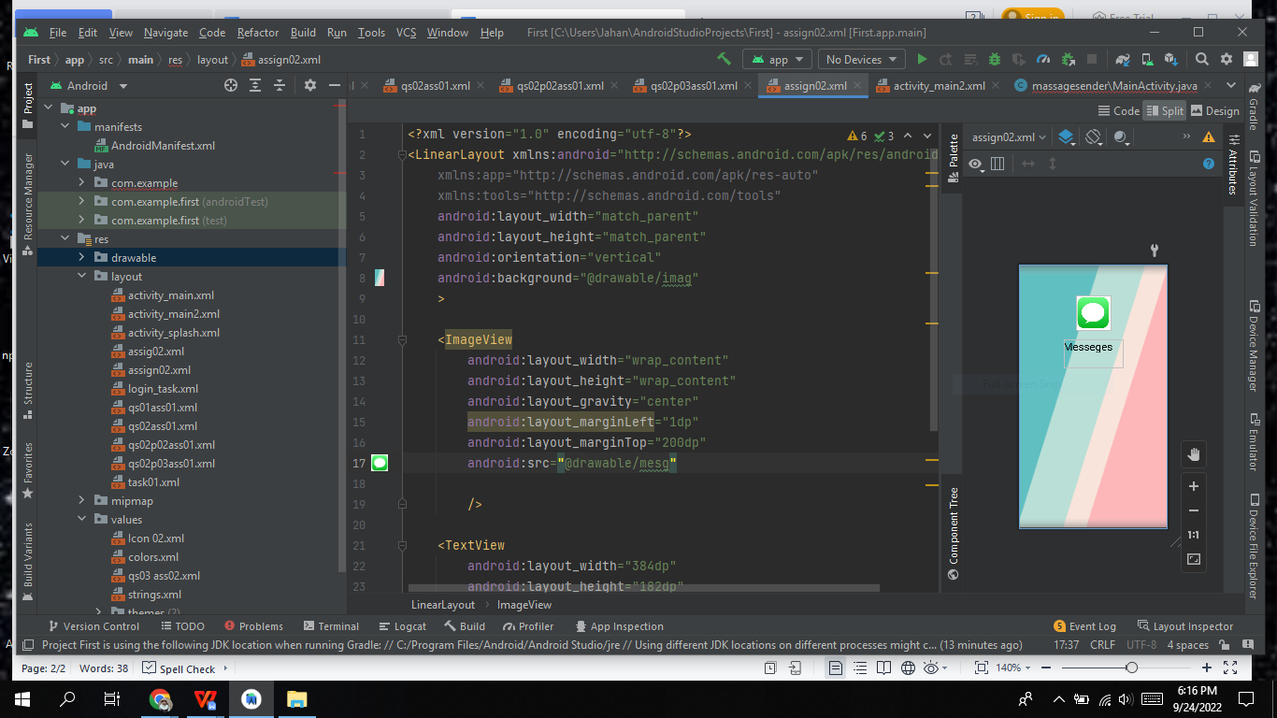

Question N0 02

<?xml version="1.0" encoding="utf-8"?>

<LinearLayout xmlns:android="http://schemas.android.com/apk/res/android"

xmlns:app="http://schemas.android.com/apk/res-auto"

xmlns:tools="http://schemas.android.com/tools"

android:layout_width="match_parent"

android:layout_height="match_parent"

android:orientation="vertical"

android:gravity="center"

tools:context=".MainActivity">

<EditText

android:textColorHint="@color/black"

android:id="@+id/Email_address"

android:hint="Enter Your Email address"

android:layout_width="match_parent"

android:layout_height="wrap_content"/>

<EditText

android:textColorHint="@color/black"

android:id="@+id/subject"

android:hint="Subject"

android:layout_width="match_parent"

android:layout_height="wrap_content"/>

<EditText

android:textColorHint="@color/black"

android:id="@+id/Mail_here"

android:hint="Email "

android:layout_width="match_parent"

android:layout_height="wrap_content"/>

<Button

android:text="send"

android:id="@+id/send"

android:layout_width="match_parent"

android:layout_height="wrap_content"/>

</LinearLayout>

package com.example.sendemail;

import androidx.appcompat.app.AppCompatActivity;

import android.content.Intent;

import android.net.Uri;

import android.os.Bundle;

import android.util.Log;

import android.view.View;

import android.widget.Button;

import android.widget.EditText;

import android.widget.Toast;

public class MainActivity extends AppCompatActivity {

Button send;

EditText address,subject,mail;

@Override

protected void onCreate(Bundle savedInstanceState) {

super.onCreate(savedInstanceState);

setContentView(R.layout.activity_main);

send = findViewById(R.id.send);

mail = findViewById(R.id.Mail_here);

subject = findViewById(R.id.subject);

address = findViewById(R.id.Email_address);

send.setOnClickListener(new View.OnClickListener() {

@Override

public void onClick(View view) {

if(mail.getText().toString().isEmpty() && subject.getText().toString().isEmpty() && address.getText().toString().isEmpty())

{

Toast.makeText(MainActivity.this, "Enter All Fields", Toast.LENGTH_SHORT).show();

}else{

Log.i("Send email", "");

String[] TO = {address.getText().toString()};

String[] CC = {"xyz@gmail.com"};

Intent emailIntent = new Intent(Intent.ACTION_SEND);

emailIntent.setData(Uri.parse("mailto:"));

emailIntent.setType("text/plain");

emailIntent.putExtra(Intent.EXTRA_EMAIL, TO);

emailIntent.putExtra(Intent.EXTRA_CC, CC);

emailIntent.putExtra(Intent.EXTRA_SUBJECT, subject.getText().toString());

emailIntent.putExtra(Intent.EXTRA_TEXT, mail.getText().toString());

try {

startActivity(Intent.createChooser(emailIntent, "Send mail..."));

finish();

} catch (android.content.ActivityNotFoundException ex) {

Toast.makeText(MainActivity.this,

"There is no email client installed.", Toast.LENGTH_SHORT).show();

}

}

}

});

}

}

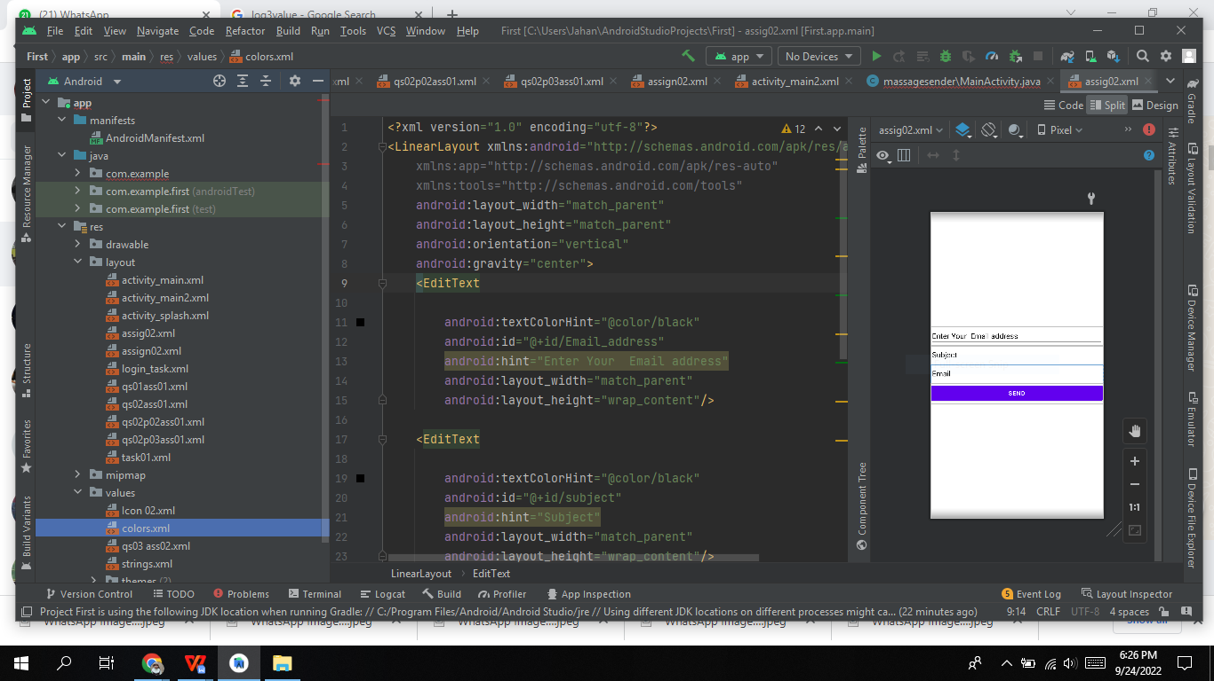

Question no 03:

<?xml version="1.0" encoding="utf-8"?>

<LinearLayout xmlns:android="http://schemas.android.com/apk/res/android"

xmlns:app="http://schemas.android.com/apk/res-auto"

xmlns:tools="http://schemas.android.com/tools"

android:layout_width="match_parent"

android:layout_height="match_parent"

android:orientation="vertical"

android:background="@drawable/fifi">

<ImageView

android:layout_width="wrap_content"

android:layout_height="wrap_content"

android:src="@drawable/webpage"

android:layout_marginTop="230dp"

android:layout_marginLeft="149dp"

/>

<TextView

android:layout_width="wrap_content"

android:layout_height="wrap_content"

android:text="Activity"

android:textSize="30dp"

android:layout_marginTop="10dp"

android:layout_gravity="center"

android:textColor="#EFD5AF"

/>

</LinearLayout>

<?xml version="1.0" encoding="utf-8"?>

<RelativeLayout xmlns:android="http://schemas.android.com/apk/res/android"

xmlns:app="http://schemas.android.com/apk/res-auto"

xmlns:tools="http://schemas.android.com/tools"

android:layout_width="match_parent"

android:layout_height="match_parent"

android:gravity="center"

tools:context=".sinlog"

android:background="@drawable/pipi">

<Button

android:background="@drawable/btnbck"

android:textColor="@color/white"

android:layout_width="match_parent"

android:layout_height="wrap_content"

android:layout_margin="10dp"

android:id="@+id/up"

android:text="Sign up"

android:textSize="30dp"

/>

<Button

android:background="@drawable/btnbck"

android:textColor="@color/white"

android:layout_width="match_parent"

android:layout_height="wrap_content"

android:layout_margin="10dp"

android:id="@+id/in"

android:layout_below="@+id/up"

android:text="Log in"

android:textSize="30dp"

/>

</RelativeLayout>

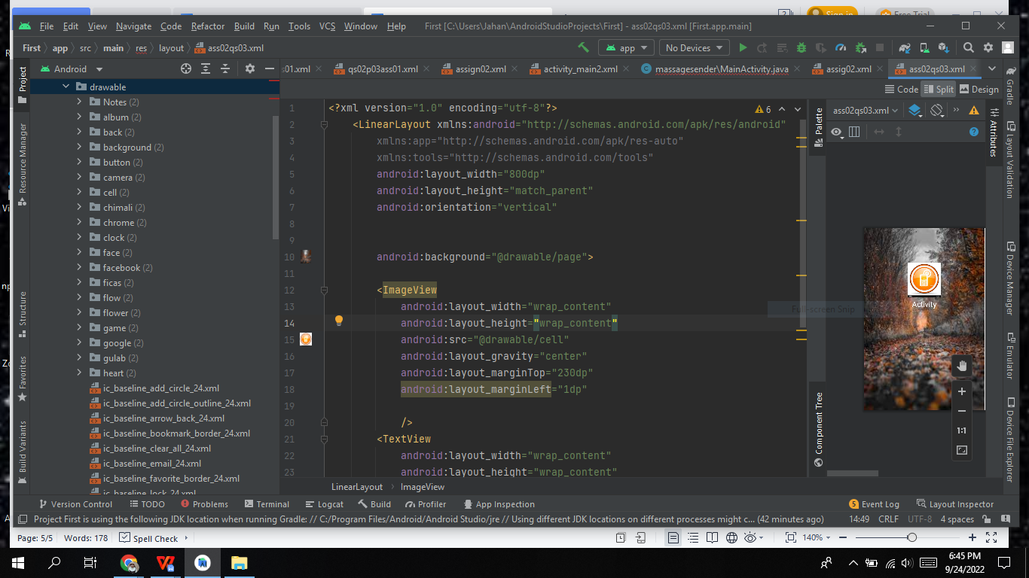

Page 02

<?xml version="1.0" encoding="utf-8"?>

<RelativeLayout xmlns:android="http://schemas.android.com/apk/res/android"

xmlns:app="http://schemas.android.com/apk/res-auto"

xmlns:tools="http://schemas.android.com/tools"

android:layout_width="match_parent"

android:layout_height="match_parent"

android:gravity="center"

tools:context=".sinlog"

android:background="@drawable/pipi">

<Button

android:background="@drawable/btnbck"

android:textColor="@color/white"

android:layout_width="match_parent"

android:layout_height="wrap_content"

android:layout_margin="10dp"

android:id="@+id/up"

android:text="Sign up"

android:textSize="30dp"

/>

<Button

android:background="@drawable/btnbck"

android:textColor="@color/white"

android:layout_width="match_parent"

android:layout_height="wrap_content"

android:layout_margin="10dp"

android:id="@+id/in"

android:layout_below="@+id/up"

android:text="Log in"

android:textSize="30dp"

/>

</RelativeLayout>

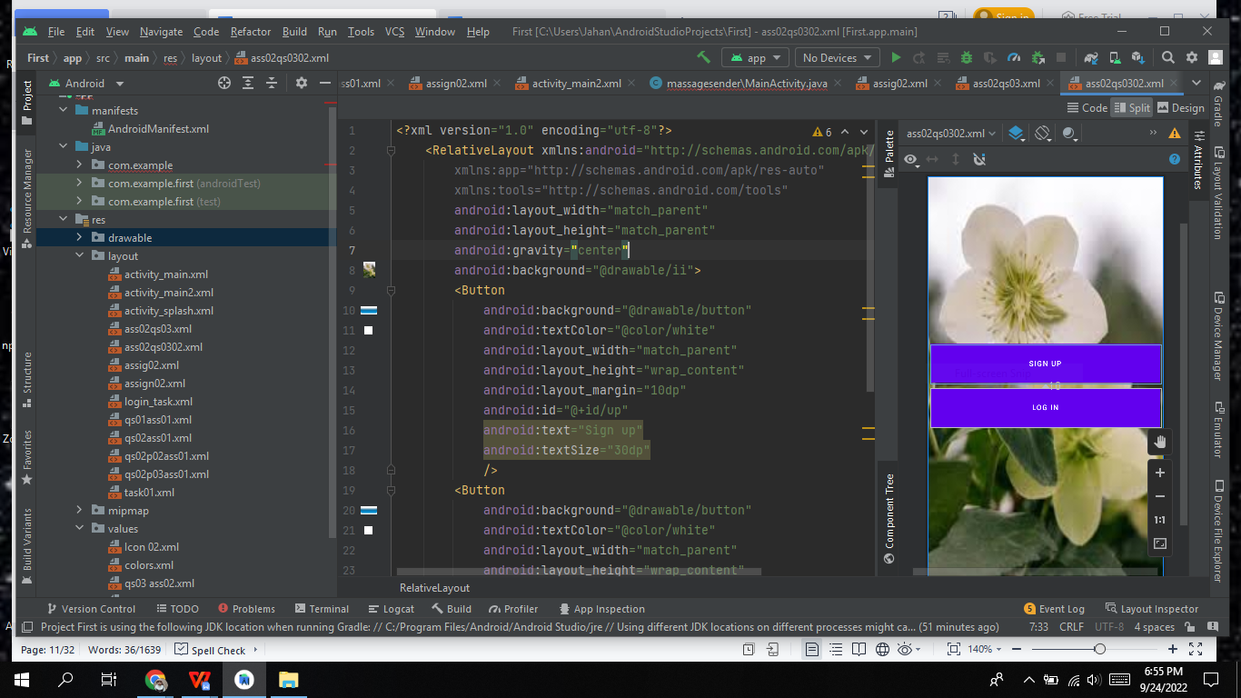

Page 03

<?xml version="1.0" encoding="utf-8"?>

<RelativeLayout xmlns:android="http://schemas.android.com/apk/res/android"

xmlns:app="http://schemas.android.com/apk/res-auto"

xmlns:tools="http://schemas.android.com/tools"

android:layout_width="match_parent"

android:layout_height="match_parent"

tools:context=".MainActivity"

android:background="@drawable/pipi"

>

<TextView

android:layout_width="match_parent"

android:layout_height="wrap_content"

android:id="@+id/signup"

android:text="sign up"

android:textSize="35dp"

android:textStyle="bold"

android:textColor="@color/white"

android:gravity="center"

android:layout_margin="25dp"

/>

<EditText

android:layout_width="match_parent"

android:layout_height="wrap_content"

android:id="@+id/username"

android:layout_below="@+id/signup"

android:background="#30ffffff"

android:hint="username"

android:textColorHint="@color/white"

android:textColor="@color/white"

android:layout_margin="10dp"

android:padding="20dp"

android:drawableLeft="@drawable/ic_baseline_info_24"

android:drawablePadding="20dp"

/>

<EditText

android:layout_width="match_parent"

android:layout_height="wrap_content"

android:id="@+id/email"

android:layout_below="@+id/username"

android:background="#30ffffff"

android:hint="email"

android:textColorHint="@color/white"

android:textColor="@color/white"

android:layout_margin="10dp"

android:padding="20dp"

android:drawableLeft="@drawable/ic_baseline_email_24"

android:drawablePadding="20dp"

/>

<EditText

android:layout_width="match_parent"

android:layout_height="wrap_content"

android:id="@+id/Password"

android:layout_below="@+id/email"

android:background="#30ffffff"

android:hint="password"

android:textColorHint="@color/white"

android:textColor="@color/white"

android:layout_margin="10dp"

android:padding="20dp"

android:drawableLeft="@drawable/ic_baseline_info_24"

android:drawablePadding="20dp"

/>

<EditText

android:layout_width="match_parent"

android:layout_height="wrap_content"

android:id="@+id/rePassword"

android:layout_below="@+id/Password"

android:background="#30ffffff"

android:hint="Re-password"

android:textColorHint="@color/white"

android:textColor="@color/white"

android:layout_margin="10dp"

android:padding="20dp"

android:drawableLeft="@drawable/ic_baseline_info_24"

android:drawablePadding="20dp"

/>

<Button

android:id="@+id/signupbtn"

android:layout_width="match_parent"

android:layout_height="wrap_content"

android:layout_below="@id/rePassword"

android:layout_centerHorizontal="true"

android:layout_marginStart="20dp"

android:layout_marginTop="20dp"

android:layout_marginEnd="20dp"

android:layout_marginBottom="20dp"

android:background="@drawable/btnbck"

android:text="Register"

android:textColor="@color/white"

android:textSize="30dp" />

<TextView

android:id="@+id/info"

android:layout_width="wrap_content"

android:layout_height="wrap_content"

android:layout_below="@id/signupbtn"

android:layout_centerInParent="true"

android:text="or sign up with"

android:textColor="@color/white"

android:textSize="20dp"

/>

<LinearLayout

android:orientation="horizontal"

android:layout_width="match_parent"

android:layout_height="wrap_content"

android:id="@+id/socialicons"

android:layout_alignParentBottom="true"

android:gravity="center"

>

<ImageView

android:layout_width="48dp"

android:layout_height="48dp"

android:src="@drawable/face"

android:layout_margin="20dp"

/>

<ImageView

android:layout_width="48dp"

android:layout_height="48dp"

android:src="@drawable/google"

android:layout_margin="20dp"

/>

<ImageView

android:layout_width="48dp"

android:layout_height="48dp"

android:src="@drawable/skype"

android:layout_margin="20dp"

/>

</LinearLayout>

</RelativeLayout><?xml version="1.0" encoding="utf-8"?>

<RelativeLayout xmlns:android="http://schemas.android.com/apk/res/android"

xmlns:app="http://schemas.android.com/apk/res-auto"

xmlns:tools="http://schemas.android.com/tools"

android:layout_width="match_parent"

android:layout_height="match_parent"

tools:context=".MainActivity"

android:background="@drawable/lili"

>

<TextView

android:layout_width="match_parent"

android:layout_height="wrap_content"

android:id="@+id/signup1"

android:text="Login"

android:textSize="35dp"

android:textStyle="bold"

android:textColor="@color/white"

android:gravity="center"

android:layout_margin="25dp"

/>

<EditText

android:id="@+id/username1"

android:layout_width="match_parent"

android:layout_height="wrap_content"

android:layout_below="@+id/signup1"

android:layout_marginStart="10dp"

android:layout_marginTop="10dp"

android:layout_marginEnd="10dp"

android:layout_marginBottom="10dp"

android:background="#30ffffff"

android:drawableLeft="@drawable/ic_baseline_info_24"

android:drawablePadding="20dp"

android:hint="username"

android:padding="20dp"

android:textColor="@color/white"

android:textColorHint="@color/white" />

<EditText

android:layout_width="match_parent"

android:layout_height="wrap_content"

android:id="@+id/email1"

android:layout_below="@+id/username1"

android:background="#30ffffff"

android:hint="email"

android:textColorHint="@color/white"

android:textColor="@color/white"

android:layout_margin="10dp"

android:padding="20dp"

android:drawableLeft="@drawable/ic_baseline_email_24"

android:drawablePadding="20dp"

/>

<EditText

android:layout_width="match_parent"

android:layout_height="wrap_content"

android:id="@+id/Password1"

android:layout_below="@+id/email1"

android:background="#30ffffff"

android:hint="password"

android:textColorHint="@color/white"

android:textColor="@color/white"

android:layout_margin="10dp"

android:padding="20dp"

android:drawableLeft="@drawable/ic_baseline_info_24"

android:drawablePadding="20dp"

/>

<Button

android:id="@+id/login1"

android:textColor="@color/white"

android:layout_width="match_parent"

android:layout_height="wrap_content"

android:layout_below="@+id/Password1"

android:layout_marginStart="10dp"

android:layout_marginTop="10dp"

android:layout_marginEnd="10dp"

android:background="@drawable/btnbck"

android:layout_marginBottom="10dp"

android:text="Login"

android:textSize="30dp" />

</RelativeLayout>

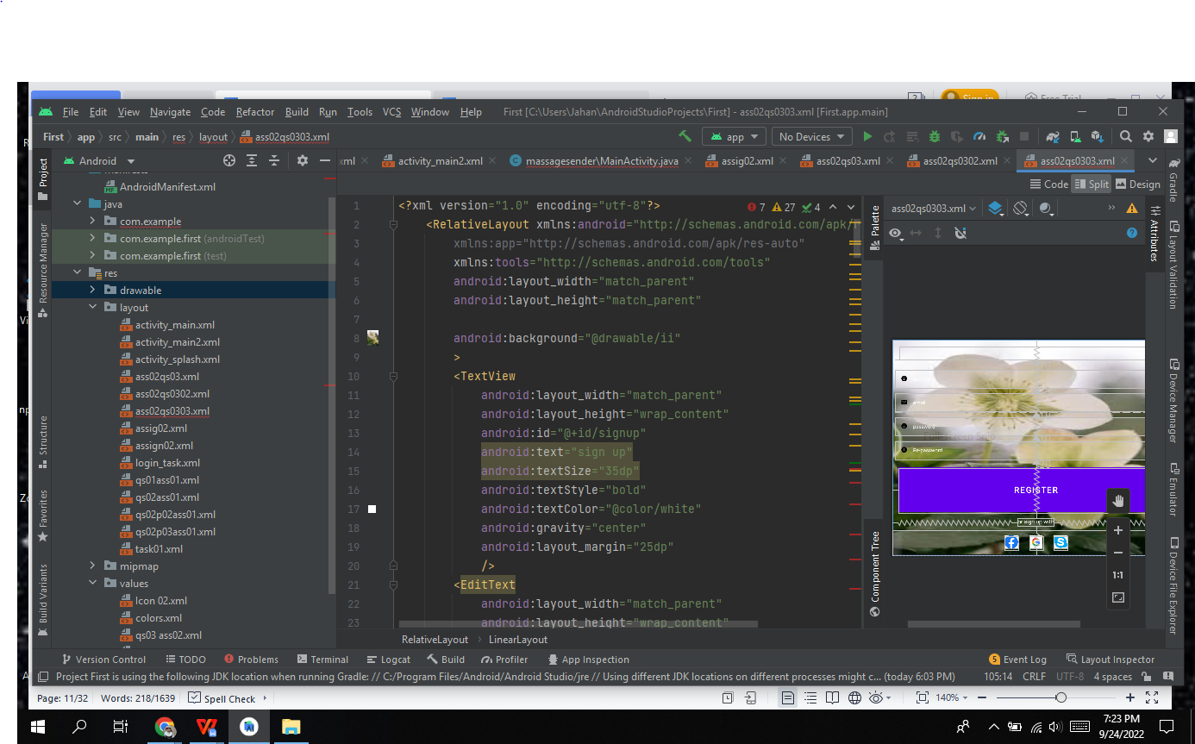

Question no 04

<?xml version="1.0" encoding="utf-8"?>

<androidx.constraintlayout.widget.ConstraintLayout

xmlns:android="http://schemas.android.com/apk/res/android"

xmlns:app="http://schemas.android.com/apk/res-auto"

xmlns:tools="http://schemas.android.com/tools"

android:layout_width="match_parent"

android:layout_height="match_parent"

android:background="#8BC34A"

android:backgroundTint="@android:color/darker_gray"

>

<!-- Text View to display our basic heading of "calculator"-->

<TextView

android:layout_width="194dp"

android:layout_height="43dp"

android:layout_marginStart="114dp"

android:layout_marginLeft="114dp"

android:layout_marginTop="58dp"

android:layout_marginEnd="103dp"

android:layout_marginRight="103dp"

android:layout_marginBottom="502dp"

android:scrollbarSize="30dp"

android:text=" Calculator"

android:textAppearance="@style/TextAppearance.AppCompat.Body1"

android:textSize="30dp"

app:layout_constraintBottom_toBottomOf="parent"

app:layout_constraintEnd_toEndOf="parent"

app:layout_constraintStart_toStartOf="parent"

app:layout_constraintTop_toTopOf="parent" />

<!-- Edit Text View to input the values -->

<EditText

android:id="@+id/num1"

android:layout_width="364dp"

android:layout_height="28dp"

android:layout_marginStart="72dp"

android:layout_marginTop="70dp"

android:layout_marginEnd="71dp"

android:layout_marginBottom="416dp"

android:background="@android:color/white"

android:ems="10"

android:onClick="clearTextNum1"

android:inputType="number"

app:layout_constraintBottom_toBottomOf="parent"

app:layout_constraintEnd_toEndOf="parent"

app:layout_constraintStart_toStartOf="parent"

app:layout_constraintTop_toTopOf="parent" />

<!-- Edit Text View to input 2nd value-->

<EditText

android:id="@+id/num2"

android:layout_width="363dp"

android:layout_height="30dp"

android:layout_marginStart="72dp"

android:layout_marginTop="112dp"

android:layout_marginEnd="71dp"

android:layout_marginBottom="374dp"

android:background="@android:color/white"

android:ems="10"

android:onClick="clearTextNum2"

android:inputType="number"

app:layout_constraintBottom_toBottomOf="parent"

app:layout_constraintEnd_toEndOf="parent"

app:layout_constraintStart_toStartOf="parent"

app:layout_constraintTop_toTopOf="parent" />

<!-- Text View to display result -->

<TextView

android:id="@+id/result"

android:layout_width="356dp"

android:layout_height="71dp"

android:layout_marginStart="41dp"

android:layout_marginTop="151dp"

android:layout_marginEnd="48dp"

android:layout_marginBottom="287dp"

android:background="@android:color/white"

android:text="result"

android:textColorLink="#673AB7"

android:textSize="25sp"

app:layout_constraintBottom_toBottomOf="parent"

app:layout_constraintEnd_toEndOf="parent"

app:layout_constraintStart_toStartOf="parent"

app:layout_constraintTop_toTopOf="parent" />

<!-- A button to perform 'sum' operation -->

<Button

android:id="@+id/sum"

android:layout_width="wrap_content"

android:layout_height="wrap_content"

android:layout_marginStart="16dp"

android:layout_marginTop="292dp"

android:layout_marginEnd="307dp"

android:layout_marginBottom="263dp"

android:backgroundTint="@android:color/holo_red_light"

android:onClick="doSum"

android:text="+"

app:layout_constraintBottom_toBottomOf="parent"

app:layout_constraintEnd_toEndOf="parent"

app:layout_constraintStart_toStartOf="parent"

app:layout_constraintTop_toTopOf="parent" />

<!-- A button to perform subtraction operation. -->

<!-- A button to perform division. -->

<Button

android:id="@+id/sub"

android:layout_width="wrap_content"

android:layout_height="wrap_content"

android:layout_marginStart="210dp"

android:layout_marginTop="292dp"

android:layout_marginEnd="113dp"

android:layout_marginBottom="263dp"

android:backgroundTint="@android:color/holo_red_light"

android:onClick="doSub"

android:text="-"

app:layout_constraintBottom_toBottomOf="parent"

app:layout_constraintEnd_toEndOf="parent"

app:layout_constraintHorizontal_bias="1.0"

app:layout_constraintStart_toStartOf="parent"

app:layout_constraintTop_toTopOf="parent"

app:layout_constraintVertical_bias="0.507" />

<Button

android:id="@+id/div"

android:layout_width="wrap_content"

android:layout_height="wrap_content"

android:layout_marginStart="307dp"

android:layout_marginTop="292dp"

android:layout_marginEnd="16dp"

android:layout_marginBottom="263dp"

android:backgroundTint="@android:color/holo_red_light"

android:onClick="doDiv"

android:text="/"

app:layout_constraintBottom_toBottomOf="parent"

app:layout_constraintEnd_toEndOf="parent"

app:layout_constraintHorizontal_bias="0.0"

app:layout_constraintStart_toStartOf="parent"

app:layout_constraintTop_toTopOf="parent" />

<!-- A button to perform multiplication. -->

<Button

android:id="@+id/mul"

android:layout_width="wrap_content"

android:layout_height="wrap_content"

android:layout_marginStart="16dp"

android:layout_marginTop="356dp"

android:layout_marginEnd="307dp"

android:layout_marginBottom="199dp"

android:backgroundTint="@android:color/holo_red_light"

android:onClick="doMul"

android:text="x"

app:layout_constraintBottom_toBottomOf="parent"

app:layout_constraintEnd_toEndOf="parent"

app:layout_constraintStart_toStartOf="parent"

app:layout_constraintTop_toTopOf="parent" />

<!-- A button to perform a modulus function. -->

<!-- A button to perform a power function. -->

<Button

android:id="@+id/button"

android:layout_width="103dp"

android:layout_height="46dp"

android:layout_marginStart="113dp"

android:layout_marginTop="356dp"

android:layout_marginEnd="206dp"

android:layout_marginBottom="199dp"

android:backgroundTint="@android:color/holo_red_light"

android:onClick="doMod"

android:text="%(mod)"

app:layout_constraintBottom_toBottomOf="parent"

app:layout_constraintEnd_toEndOf="parent"

app:layout_constraintStart_toStartOf="parent"

app:layout_constraintTop_toTopOf="parent"

app:layout_constraintVertical_bias="0.515" />

<Button

android:id="@+id/pow"

android:layout_width="wrap_content"

android:layout_height="wrap_content"

android:layout_marginStart="113dp"

android:layout_marginTop="292dp"

android:layout_marginEnd="210dp"

android:layout_marginBottom="263dp"

android:backgroundTint="@android:color/holo_red_light"

android:onClick="doPow"

android:text="n1^n2"

app:layout_constraintBottom_toBottomOf="parent"

app:layout_constraintEnd_toEndOf="parent"

app:layout_constraintHorizontal_bias="0.0"

app:layout_constraintStart_toStartOf="parent"

app:layout_constraintTop_toTopOf="parent"

app:layout_constraintVertical_bias="0.507" />

</androidx.constraintlayout.widget.ConstraintLayout>

package com.example.lab4;

import android.os.Bundle;

import com.example.caloo.R;

import com.google.android.material.snackbar.Snackbar;

import androidx.appcompat.app.AppCompatActivity;

import android.text.TextUtils;

import android.view.View;

import android.view.Menu;

import android.view.MenuItem;

import android.os.Bundle;

import android.view.View;

import android.widget.EditText;

import android.widget.TextView;

import androidx.appcompat.app.AppCompatActivity;

public class MainActivity extends AppCompatActivity {

private AppBarConfiguration appBarConfiguration;

private ActivityMainBinding binding;

public EditText e1, e2;

TextView t1;

int num1, num2;

public boolean getNumbers() {

//checkAndClear();

// defining the edit text 1 to e1

e1 = (EditText) findViewById(R.id.num1);

// defining the edit text 2 to e2

e2 = (EditText) findViewById(R.id.num2);

// defining the text view to t1

t1 = (TextView) findViewById(R.id.result);

// taking input from text box 1

String s1 = e1.getText().toString();

// taking input from text box 2

String s2 = e2.getText().toString();

if(s1.equals("Please enter value 1") && s2.equals(null))

{

String result = "Please enter value 2";

e2.setText(result);

return false;

}

if(s1.equals(null) && s2.equals("Please enter value 2"))

{

String result = "Please enter value 1";

e1.setText(result);

return false;

}

if(s1.equals("Please enter value 1") || s2.equals("Please enter value 2"))

{

return false;

}

if((!s1.equals(null) && s2.equals(null))|| (!s1.equals("") && s2.equals("")) ){

String result = "Please enter value 2";

e2.setText(result);

return false;

}

if((s1.equals(null) && !s2.equals(null))|| (s1.equals("") && !s2.equals("")) ){

//checkAndClear();

String result = "Please enter value 1";

e1.setText(result);

return false;

}

if((s1.equals(null) && s2.equals(null))|| (s1.equals("") && s2.equals("")) ){

//checkAndClear();

String result1 = "Please enter value 1";

e1.setText(result1);

String result2 = "Please enter value 2";

e2.setText(result2);

return false;

}

else {

// converting string to int.

num1 = Integer.parseInt(s1);

// converting string to int.

num2 = Integer.parseInt(s2);

}

return true;

}

public void doSum(View v) {

// get the input numbers

if (getNumbers()) {

int sum = num1 + num2;

t1.setText(Integer.toString(sum));

}

else

{

t1.setText("Error Please enter Required Values");

}

}

public void clearTextNum1(View v) {

// get the input numbers

e1.getText().clear();

}

public void clearTextNum2(View v) {

// get the input numbers

e2.getText().clear();

}

public void doPow(View v) {

//checkAndClear();

// get the input numbers

if (getNumbers()) {

double sum = Math.pow(num1, num2);

t1.setText(Double.toString(sum));

}

else

{

t1.setText("Error Please enter Required Values");

}

}

// a public method to perform subtraction

public void doSub(View v) {

//checkAndClear();

// get the input numbers

if (getNumbers()) {

int sum = num1 - num2;

t1.setText(Integer.toString(sum));

}

else

{

t1.setText("Error Please enter Required Values");

}

}

// a public method to perform multiplication

public void doMul(View v) {

//checkAndClear();

// get the input numbers

if (getNumbers()) {

int sum = num1 * num2;

t1.setText(Integer.toString(sum));

}

else

{

t1.setText("Error Please enter Required Values");

}

}

// a public method to perform Division

public void doDiv(View v) {

//checkAndClear();

// get the input numbers

if (getNumbers()) {

// displaying the text in text view assigned as t1

double sum = num1 / (num2 * 1.0);

t1.setText(Double.toString(sum));

}

else

{

t1.setText("Error Please enter Required Values");

}

}

// a public method to perform modulus function

public void doMod(View v) {

//checkAndClear();

// get the input numbers

if (getNumbers()) {

double sum = num1 % num2;

t1.setText(Double.toString(sum));

}

else

{

t1.setText("Error Please enter Required Values");

}

}

@Override

protected void onCreate(Bundle savedInstanceState) {

super.onCreate(savedInstanceState);

setContentView(R.layout.activity_main);

e1 = (EditText) findViewById(R.id.num1);

// defining the edit text 2 to e2

e2 = (EditText) findViewById(R.id.num2);

}

@Override

public boolean onCreateOptionsMenu(Menu menu) {

// Inflate the menu; this adds items to the action bar if it is present.

getMenuInflater().inflate(R.menu.menu_main, menu);

return true;

}

@Override

public boolean onOptionsItemSelected(MenuItem item) {

// Handle action bar item clicks here. The action bar will

// automatically handle clicks on the Home/Up button, so long

// as you specify a parent activity in AndroidManifest.xml.

int id = item.getItemId();

//noinspection SimplifiableIfStatement

return super.onOptionsItemSelected(item);

}

}

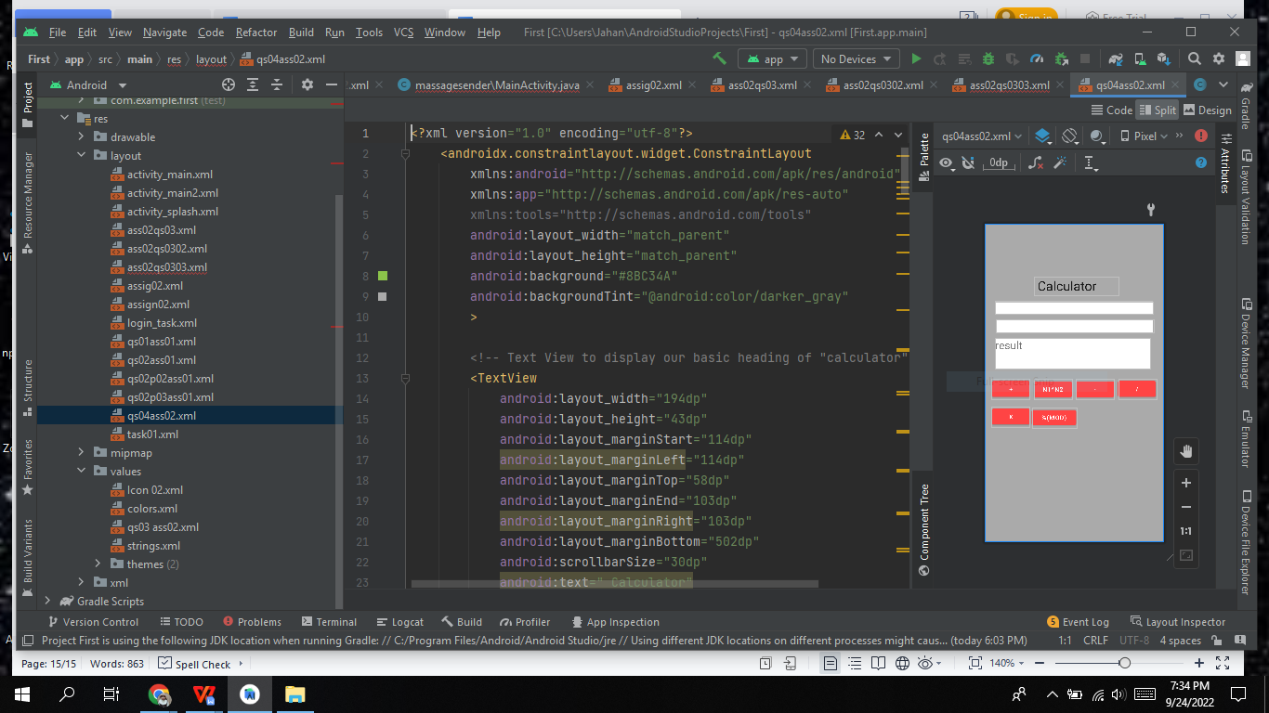

Question no 05

<?xml version="1.0" encoding="utf-8"?>

<LinearLayout xmlns:android="http://schemas.android.com/apk/res/android"

android:orientation="vertical"

android:layout_width="match_parent"

android:layout_height="match_parent">

<ImageView

android:id="@+id/I1"

android:layout_width="wrap_content"

android:layout_height="wrap_content"

android:src="@drawable/download"/>

<EditText

android:id="@+id/edit1"

android:layout_width="match_parent"

android:layout_height="wrap_content"

android:ems="10"

android:hint="Enter Email"

/>

<EditText

android:id="@+id/edit2"

android:layout_width="match_parent"

android:layout_height="wrap_content"

android:ems="10"

android:hint="Enter Password"/>

<Button

android:id="@+id/b1"

android:layout_width="wrap_content"

android:layout_height="wrap_content"

android:text="Login" />

<?xml version="1.0" encoding="utf-8"?>

<LinearLayout xmlns:android="http://schemas.android.com/apk/res/android"

android:orientation="vertical"

android:layout_width="match_parent"

android:layout_height="match_parent">

<ImageView

android:id="@+id/I1"

android:layout_width="wrap_content"

android:layout_height="wrap_content"

android:src="@drawable/download"/>

<EditText

android:id="@+id/edit1"

android:layout_width="match_parent"

android:layout_height="wrap_content"

android:ems="10"

android:hint="Enter Email"

/>

<EditText

android:id="@+id/edit2"

android:layout_width="match_parent"

android:layout_height="wrap_content"

android:ems="10"

android:hint="Enter Password"/>

<Button

android:id="@+id/b1"

android:layout_width="wrap_content"

android:layout_height="wrap_content"

android:text="Login" />

</LinearLayout>